Qualcomm Inc.

ITG #298967

Functional Specification Document

Custom Labels for Nokia

Author : Tracy Henry

Creation Date : July 25, 2011

Last Updated : January 26, 2012

Version : 2.1

## Document Control

**Change Record**

| Date | Author | Version | Change Reference |
| --- | --- | --- | --- |
|  |  |  |  |
| 7/25/11 | Tracy Henry | 1.0 | Initial Creation |
| 10/04/11 | Tracy Henry | 2.0 | Add Schenker changes: COO and inner LPN barode |
| 01/26/12 | Tracy Henry | 2.1 | Add three Nokia customer account numbers for the label |

**Reviewers**

| Name | Position |
| --- | --- |
|  |  |
| Merwin Wilfred | Director, Operations |
| Kenneth Hatfield | IT Systems Analyst |
| Dennis Low | Schenker IT |
|  |  |

**Distribution**

| Copy No. | Name | Location |
| --- | --- | --- |
|  |  |  |
|  |  |  |
|  |  |  |
|  |  |  |

Contents

Document Control ii

Overview and Functional Solution 1

Open and Closed Issues 6

Open Issues 6

Closed Issues 6

## Overview and Functional Solution

In order to implement the Nokia VMI solution, there are three custom labels required. It is requested that Schenker provide resources for the following development: a custom inner box label, a custom outer box label, and a custom pallet label. The labels will be driven off specific customer ship to IDs in the 3B12 message.

The field in the 3B12 that indicates the customer ship to address is SHIP_TO_CUSTOMER_ID.

The specific customer ship to IDs for these labels will be:

84654 – Nokia Telecommunications Ltd

84174 – NOKIA TMC

79374 – Nokia Corporation

83874    for Nokia VMI Replenishment - Masan

83894    for Nokia VMI Replenishment - Beijing

The supplier number is 507725. This number will appear where the label images show [SUPPLIER_NUMBER]. Supplier number is referenced in the (Z), (1J), and (2J) fields.

1. Custom Inner Box Label

There are no field labels on the inner box label. For the (P), (Q), (Z), there will be a DFID followed by the actual value for that field on the order for that product. There will be barcodes for (P), (Q), (Z) underneath. Three fields will be shown on the right without DFIDs or barcodes. Supplier Code and Date will have human readable label. COO will not have human readable label.

**NOTE: The original requirement as given to Schenker was modified to allow for scanning validation of the COO. See closed issues.**

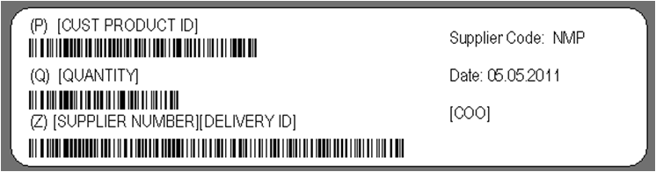

Field Definitions:

|  |  |  |
| --- | --- | --- |
| Field Label | Definition | 3B12 Field |
| (P) | Customer Product ID | CUSTOMER_ITEM_NAME |
| (Q) | Quantity in the inner box | Generate from Exceed |
| (Z) | Traceability Number – defined as 6 digit static supplier identification number followed by the delivery ID | 507725[DELIVERY_ID] |
| Supplier Code: | always show NMP | Hardcode value = NMP |
| Date: | The date the label was printed in the format DDMMYY | Generate from Exceed |
| COO: | Will be displayed only as a two digit country code with no field label | COUNTRY_OF_ORIGIN |

1. Outer Carton Label

The outer carton label will display the ship to and ship from addresses at the top. Underneath are (1J), (K), (P) (Q), (Z), and (4L), all with DFIDs, field labels, and barcodes underneath. The remaining 4 fields will have field labels, but no DFIDs or barcodes.

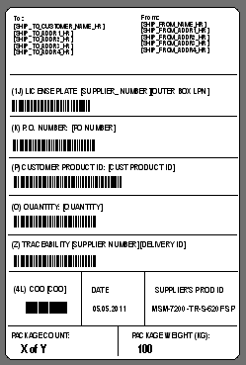

Field Definitions:

|  |  |  |
| --- | --- | --- |
| Field Label | Definition | 3B12 Field |
| (1J) License Plate: | Six digit static supplier ID number followed by the outer carton LPN number - bar-coded | 507725[LPN] |
| (K) P.O. Number: | Customer PO number - bar-coded | CUSTOMER_PO_NUMBER |
| (P) Customer Product ID: | Customer Product ID - bar-coded | CUSTOMER_ITEM_NAME |
| (Q) Quantity: | Quantity in the outer box - bar-coded | Generate from Exceed |
| (Z) Traceability Number | Defined as 6 digit static supplier identification number followed by the delivery ID - bar-coded | 507725[DELIVERY_ID] |
| (4L) COO: | Country of origin. Display as a two digit country code – bar-coded. This needs to be one value for each outer box. | Generate from Exceed |
| Date: | The date the label was printed in the format DDMMYY | Generate from Exceed |
| Supplier Prod ID | Qualcomm’s item description | ITEM_DESCRIPTION |
| Package Count | X of Y boxes in the shipment | Generate from Exceed |
| Package Weight | display in KG | Generate from Exceed |

1. Pallet Label

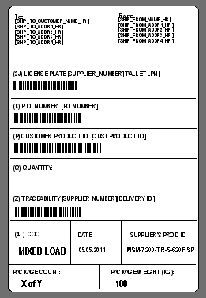

Field Definitions:

|  |  |  |
| --- | --- | --- |
| Field Label | Definition | 3B12 Field |
| (2J) License Plate: | Six digit static supplier ID number followed by the pallet LPN number - bar-coded | 507725[PLPN] |
| (K) P.O. Number: | Customer PO number - bar-coded | CUSTOMER_PO_NUMBER |
| (P) Customer Product ID: | Customer Product ID - bar-coded | CUSTOMER_ITEM_NAME |
| (Q) Quantity: | Quantity in the pallet – bar-coded. This is left blank if there is more than one COO in the pallet | Generate from Exceed, if applicable by the definition |
| (Z) Traceability Number | Defined as 6 digit static supplier identification number followed by the delivery ID - bar-coded | 507725[DELIVERY_ID] |
| (4L) COO: | Country of origin. Display as a two digit country code – bar-coded. If there are mixed COOs in the pallet, indicate MIXED LOAD in this field. | Generate from Exceed or hard code, if applicable by the definition |
| Date: | The date the label was printed in the format DDMMYY | Generate from Exceed |
| Supplier Prod ID | Qualcomm’s item description | ITEM_DESCRIPTION |
| Package Count | X of Y boxes in the shipment | Generate from Exceed |
| Package Weight | display in KG | Generate from Exceed |

## 

## Open and Closed Issues

### Open Issues

### Closed Issues

In order to meet the requirement for including the COO on the inner box, Schenker required an inclusion of the COO barode and the TAP inner box LPN barcode. This is in order for them to perform a scanning valiudation on the inner box label to assure they have affixed the correct label to the correct box. Below is the final look of the inner boxlabel (referred to by Nokia as the product package label).

Inner Box Label

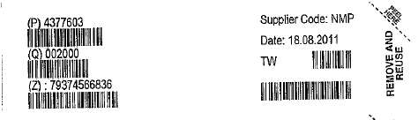

Images of the other labels from Schenker’s system:

Outer Carton Label

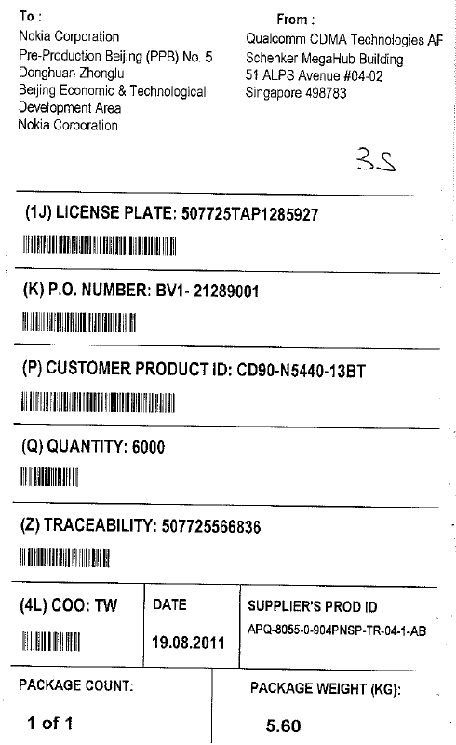

Pallet Label

